Phoenix Aircraft Arresting Control System

Global Data Specialists, a value-added reseller and systems integrator of Supervisory Control and Data Acquisition (SCADA) systems, offers a turn-key aircraft arresting control system. Global Data Specialists’ PAACS (Phoenix Aircraft Arresting Control System) allows an airport control tower operator to monitor and control aircraft arresting mechanisms located at either end of an airport runway.

The aircraft arresting control system raises and lowers the arresting system that is used to bring an aircraft to a stop during an emergency, and in training pilots to handle emergencies. The arresting system is normally used during take-off or landing of military aircraft. Aircraft arresting control systems utilize arresting cables or nets at one or both ends of a single runway or on multiple runways.

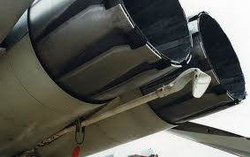

Aircraft arresting control systems are typically located in barrier pits or shacks situated at the ends of runways. Many of these systems currently in operation are antiquated, and require manual operation. A manual system typically comprises a winch, pneumatic and mechanical devices, and electrical controls to allow an operator who is physically present at the barrier pit to raise and lower the cable manually. This is time consuming, labor intensive, and requires physical presence at the barrier pit.

PAACS is a modern, automated, and reliable aircraft arresting control system based on advanced radio communication. A control panel located in the airport control tower allows a single operator to manage up to four cable systems simultaneously (one or two arresting systems per runway, and one or two runways).

PAACS uses the Motorola® ACE3600 SCADA system to provide remote control of aircraft arresting mechanisms. The primary control panel situated in the airport control tower controls the aircraft arresting mechanism. PAACS allows remote access for off-site operation.

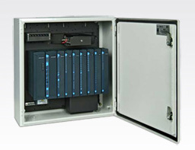
While the main control panel is used to control the aircraft arresting mechanism, a secondary panel may be used at the control tower to monitor the following conditions:
- Runway communication status
- Runway AC power status
- Cable up/down status
A third panel, typically a fire station panel, which is usually located elsewhere and not in the control tower, may be used to monitor a barrier pit for the following conditions:
- Water alarm status (flooding; for below-ground installations)
- Fire alarm status
- Low Air alarm status
- Air Quality alarm status (Oxygen, CO, and low explosive level

PAACS is renowned for its reliability and ease of use. Global Data Specialists has deployed nearly 100 PAACS systems. PAACS is a complete solution that includes a remote terminal unit, power supply, battery backup, radio systems, antennas, control panels, wiring, enclosures, and additional devices such as air quality sensors. Additionally, Global Data Specialists offers pre and post-sales support, installation and startup, training, preventive maintenance, and warranty and non-warranty repair services.

To learn more about PAACS:
480-461-3401 or
sales@gbl-data.com

