Motorola SCADA Solution for Electric Utilities

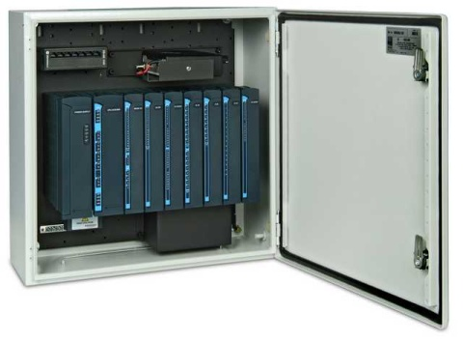
Global Data Specialists’ (GDS) Electric Utility application for Motorola’s Supervisory Control and Data Acquisition (SCADA) Remote Terminal Units (RTU) is a key component of an Electric Utility’s distribution automation systems. Utilities enjoy world-class reliability, high security, ease-of-use, proven low total cost of ownership, and industry leading communications from their investment in Motorola SCADA systems.

Several electric utilities have deployed GDS & Motorola’s SCADA system in their distribution automation operations. They utilize these systems in its network primarily for:
- Line switching operations
- Control reclosure operation (i.e. Cooper Switches)
- Motor Operated Air Breaks (MOAB)

As an example, one utility operates over 1,200 RTUs in its network over seven separate communications zones. This company uses the majority of its RTUs for line switching. which minimizes the requirement for a lineman to have to go on site. The utility uses the built in capability of the Motorola SCADA system’s power supply to detect loss of incoming power as a first indicator of line failure. These RTUs monitor power for power lines ranging from 12KV to 115KV.
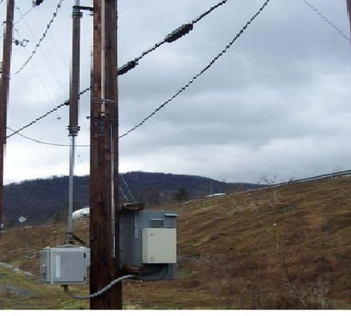
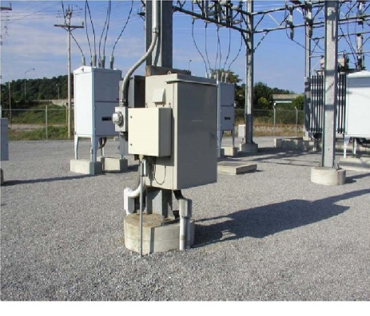
RTUs that are used for sectionalizing have custom logic programmed in them. This capability, combined with support for 3rd party communication protocols such as MODBUS and DNP3, allows RTUs to interface to Cooper Switches and other reclosure equipment, which provides sectionalizing and the ability to restore power quickly. The communications interface to the Cooper Switch provides status information about the switch equipment to operations personnel at the network operations center. Motorola SCADA system’s 3rd party communication protocols and ports allows RTUs to interface to Intelligent Electronic Devices and smart sensors for monitoring and control.

The communications capabilities and flexibility of Motorola SCADA systems allows customers to interface to a variety of communication methods such as VHF, UHF, 800MHz, and 900MHz radio systems either Analog or Digital; Cell Modems; Ethernet; and RS232/RS485. This allows the electric utility to take advantage of multiple communications options to reach out from their main operations centers to the furthest and/or remotest locations in their distribution network.

Motorola SCADA systems offer timely and actionable information to electric utility operations personnel so that they can meet their customer demands in a cost effective and expeditious manner. The proven reliability and durability of Motorola SCADA systems continues to yield Electric Utilities a superior return on their investment.

For additional information, please contact Global Data Specialists at sales@gbl-data.com or 480-461-3401.

