**Motorola Compliance Connect Spreadsheet**

**User Guide v7.0**

**May 10, 2013**

# 

Table of Contents

Introduction 1

General Process for Spreadsheet Completion 1

Software Requirements 3

Opening Compliance Connect 3

Spreadsheet Tabs Descriptions 4

Populating the Spreadsheet (BLUE TABS on spreadsheet) 5

General Data Entry Tips 5

General Data Entry Process Flow 6

Complete the General Information Tab 8

Full or Partial Declaration: Part Tree Tab for Component Information 12

Full Declaration Only: Materials Tab 15

Full Declaration Only: Part Details Tab 19

Partial Declaration Only: “Motorola Intelligent Query” Tab 23

Full or Partial Declaration: “Certify and Export” 25

Utilities Tab 27

Import Tab-Delimited Text File 27

Export Tab-Delimited Text File 29

Import Motorola Configuration File 29

Troubleshooting FAQ 30

VB Compile Error 30

Declaration Level Validation Errors 31

# Introduction

To assist suppliers in fulfilling their compliance reporting requirements, Motorola Solutions is using an Excel Solution called the “Intelligent Compliance Connect” spreadsheet.

## General Process for Spreadsheet Completion

1. Open the file that has been sent to you and enable macros.
2. Complete the General Information tab.
3. If filling out a Full & Partial Material Declaration:
   * 1. Complete the Part Tree tab for each requested part (including sub-components, if applicable)
     2. Complete the Materials tab for each material used in the bottom (leaf) level components.
     3. Complete the Part Detail tab by linking each bottom level component to the respective material(s).
     4. Complete the “Motorola Intelligent Query” Tab
     5. Click the “Certify and Export” button, and submit the “.mcc” file to your customer.
4. If filling out a Full Material Declaration
   * 1. Complete the Part Tree tab for each requested part (including sub-components, if applicable)
     2. Complete the Materials tab for each material used in the bottom (leaf) level components.
     3. Complete the Part Detail tab by linking each bottom level component to the respective material(s).
     4. Click the “Certify and Export” button, and submit the “.mcc” file to your customer.
5. If filling out a Partial Material Declaration
   * 1. Complete the Part Tree tab for each requested part (including sub-components, if applicable)
     2. Complete the “Motorola Intelligent Query” Tab
     3. Click the “Certify and Export” button, and submit the “.mcc” file to your customer

## Software Requirements

To open the Compliance Connect Spreadsheet, user must have one of the following Microsoft operating systems/Excel versions:

* Windows XP/Excel 2003 or higher (recommended)
* Windows XP/Excel 2007 or higher (recommended)
* Windows Vista/Excel 2007 or higher (recommended)
* Windows 7/Excel 2007 or higher (recommended)

## Opening Compliance Connect

Every time the spreadsheet is opened, the user will be prompted to enable or disable macros (depending upon how they have their Macro Security set within Microsoft Excel). It is CRITICAL that the **macros are enabled**; otherwise, the spreadsheet will not function. If macros will not run, it may be necessary to change the Microsoft Excel security settings to enable macros.

PLEASE NOTE:

It is recommended to save a working copy of the spreadsheet on the desktop to avoid any issues related to lengthy filenames causing run-time errors.

If the user experiences this issue/error message shown below, it is due to hidden .exd cache files.

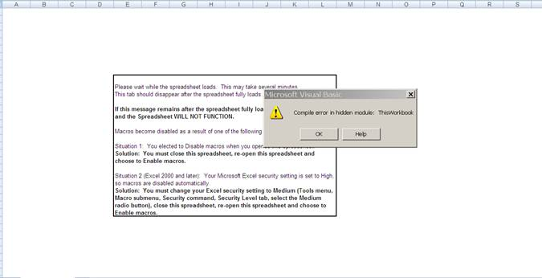

To resolve this error, the user has to delete the .exd files. since .exd files store cached information about controls installed with a Microsoft Office file. This allows for faster processing of the file. The location of these files differs from one Operating System to another and differ based on the version of Office installed. Please see page 30 for the exact steps to clear this out of the computer’s cache.

## Spreadsheet Tabs Descriptions

Once the spreadsheet is open, the user will see a number of Microsoft Excel Worksheets with color-coded tabs along the bottom:

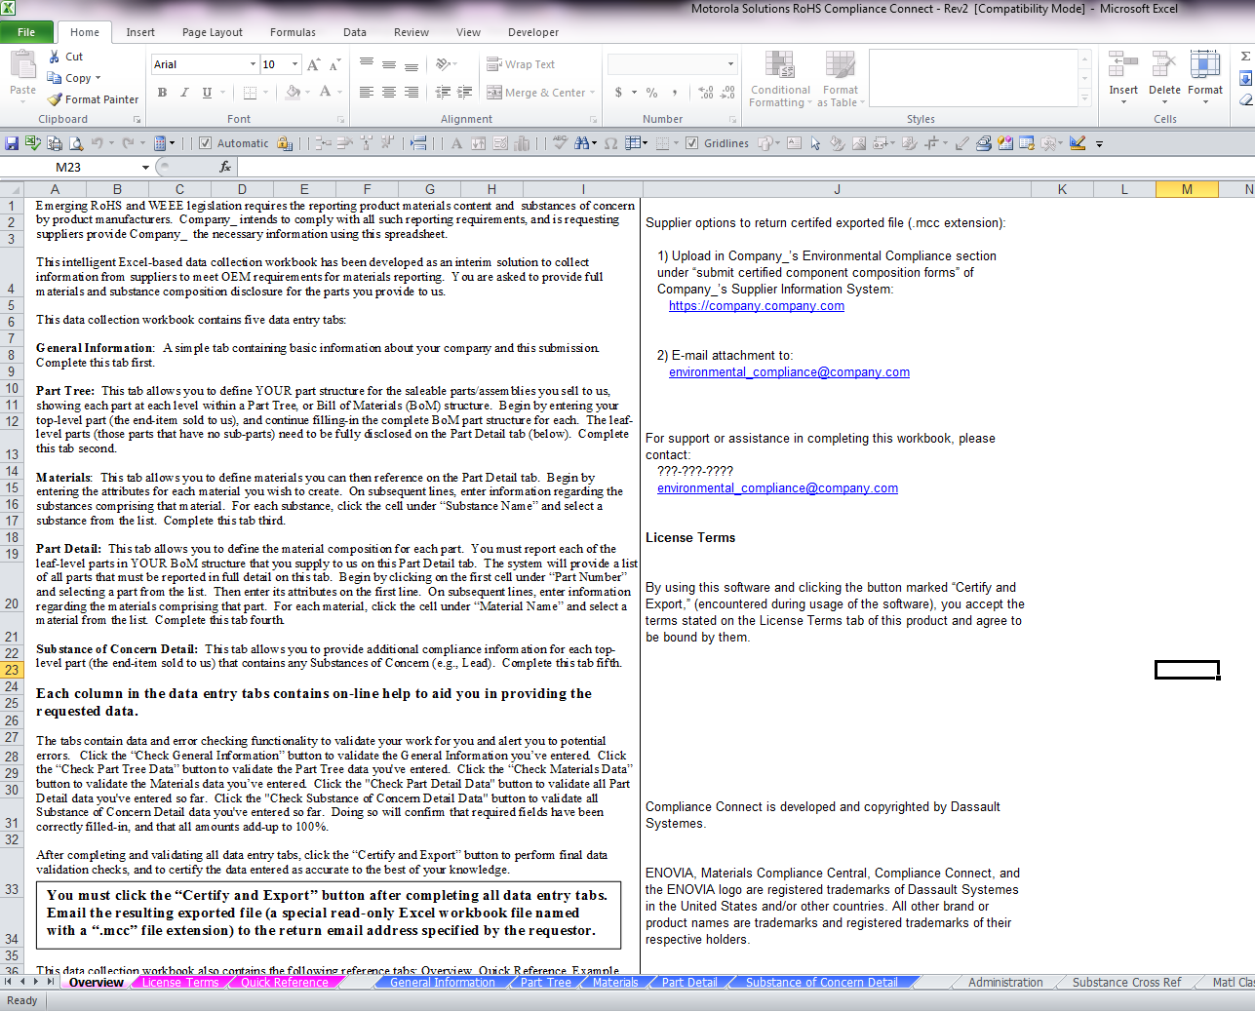

**Pink** – Informative, what every user should know

* Overview – Describes purpose and use of the spreadsheet
* License Terms – Agreement for using the spreadsheet
* Quick Reference – Provides hyperlinks to the “Overall Help” tabs and outlines general steps for completing the spreadsheet

**Blue** – User data input (described further in the next section)

* General Information on the supplier
* Part Tree – Bill of Material layout for each part
* Materials – Material library showing the chemical composition of every material used in the parts
* Part Detail – Links parts with materials, contains the “Certify and Export” button
* “Motorola Intelligent Query”
* Substance of Concern - This tab is typically used to propose new part numbers, changes in compliance information on a supplier part. Data entry on this tab is not required by Motorola. The user does not have to fill in values into this tab.

**Green** – Displays an example for each User input tab

* Part Tree Example
* Materials Example
* Part Detail Example

**Other Tabs**

* Administration
* Part Tree Overall Help
* Materials Overall Help
* Part Detail Overall Help
* Utilities
* End of User Tabs – Signifies the end of the User tabs. Remaining tabs to the right are for ENOVIA internal use only and should be ignored by user.

# Populating the Spreadsheet (BLUE TABS on spreadsheet)

## General Data Entry Tips

1. Each data entry tab contains mandatory entry fields and entry fields that are optional. A **BOLD** heading indicates a **Mandatory field**. It should be noted that many mandatory fields do allow “N/A” to be entered. Refer to the data field help box titled “Column Help” (this will appear at the top left of your screen) and the Requestor’s data standards to see if entering “N/A” is acceptable.
2. Some data entry fields require a particular format for listing multiple items. Refer to the column help to view any specific formatting requirements.
3. Each data entry tab contains a green check button in the upper left corner of the spreadsheet. After data has been entered, the user should utilize the “**Check… Button**” for that tab to ensure all required fields have been entered appropriately.
4. Each data entry tab contains a column help feature which will appear in the top portion of the spreadsheet. With this feature enabled, the user can obtain additional guidance on the particular column by clicking the column heading. The information indicated in the Column Help will NOT change until the supplier clicks in another data entry box.
5. The spreadsheet may be used to report multiple part numbers.
6. It is recommended that the user periodically save the work in progress (using the standard Excel File->Save or Save As function), particularly after finishing data entry into each of the worksheets.
7. The Part Tree, Materials, and Part Detail tabs contain additional buttons for adding or deleting rows. Use these buttons instead of the Excel Menu’s Insert/Delete rows that are found on the spreadsheet in Row 3 and 4 (column I through R).

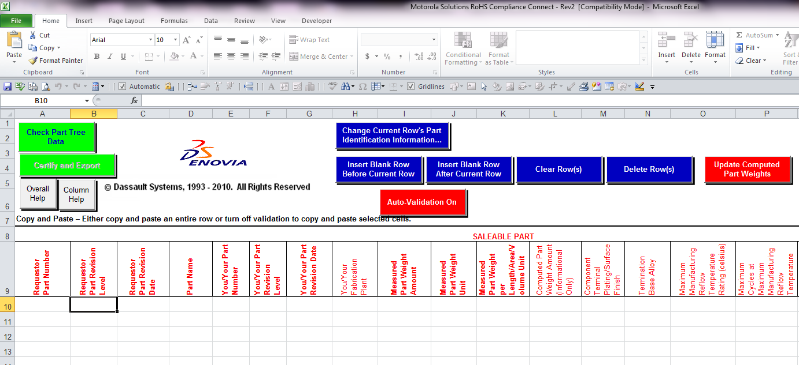

## General Data Entry Process Flow

The three flow charts below provide a high level data entry process flow. These charts can be used as a guideline to perform the data entry process depending on the type of data being entered

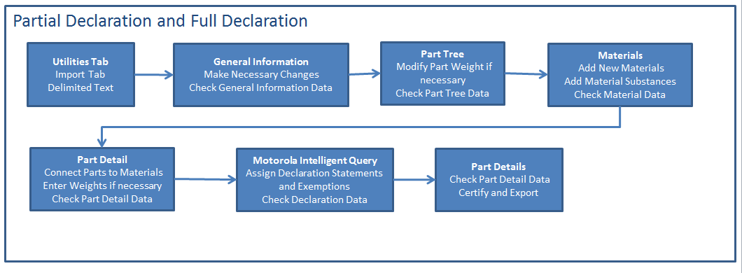

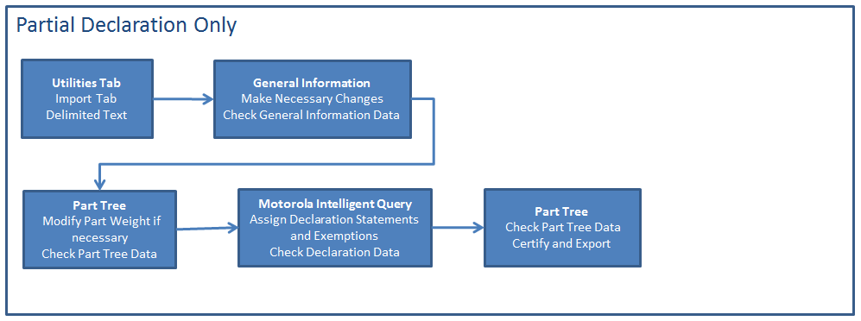

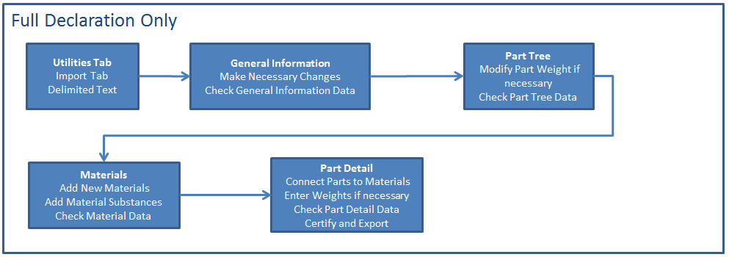

## Complete the General Information Tab

The user should provide general information about the company on this tab such as address and contact information. Refer to Table 1, General Information Tab Guidance, for additional information.

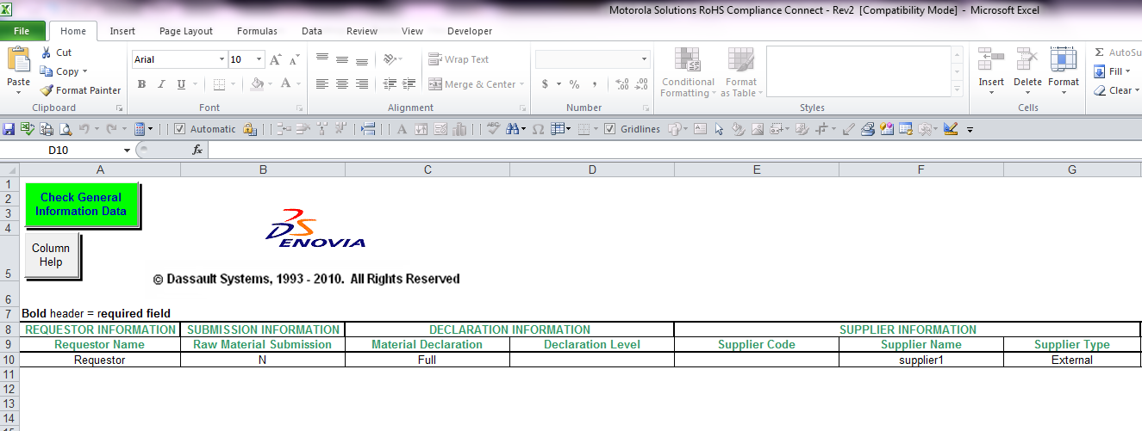

| **Table 1. General Information Tab Guidance** | | | |
| --- | --- | --- | --- |
| **Column Name** | **Sub-Column Name** | **Information Description** | **Status (Required or Optional)** |
| Requestor information | Requestor Name | Customer Name. The name of the company requesting the data. | Required |
| Submission information | Raw Material Submission | Select “Y” if you are supplying raw material compositions or un-finished material (i.e., castings, tubing) compositions only.  Select “N” if you are supplying part/component information. | Required |
| Declaration Information | Material Declaration | Select “Full” if you are supplying material and substance data. Select “Partial” if you are supplying “Yes/No/Yes with exemptions” declaration statement only  If a pre-populated file is provided, this field will be automatically populated upon import. | Required |
| Declaration Level | Select the “Compliance Definition” or regulation for which you plan on submitting the yes/no declaration statement. Dependent upon what you choose will modify the overall spreadsheet tabs. (e.g. If you click on “RoHS/MSI W18” from the pull-down menu, “RoHS” will appear in the Declaration Level Box…and the **Motorola Intelligent Query** tab will appear after the **Substance of Concern Detail** tab.)  If a pre-populated file is provided, this field will be automatically populated upon import. | Required |
| Supplier information | Supplier Code | Enter your supplier code as recognized by your customer, also known as the MSI “epims id” number. | Required: Pre-entered by the EDM Penang team. |
| Supplier Name | Enter your company name. | Required: Pre-entered by the EDM Penang team. |
| Supplier Type | Select “Internal” if you are a plant or division of the requestor. If you are the requestor’s supplier, select “External.” | Required |
| Supplier contact information | Name, E-mail, Telephone, Fax | Enter the information of your contact responsible for this data and who can answer questions regarding information provided. | Required |
| Additional Supplier Contact Information | Title, Department, Mail Code, Cell | Additional information for the individual listed as the contact. | Optional |
| Supplier Contact Address Information | Address 1, Address 2, City, State/Province, Zip/Postal Code, Country | Additional information for the individual listed as the contact | Optional |

EXAMPLES of what will appear based upon what is entered on the General Information Tab:



Full Disclosure Only

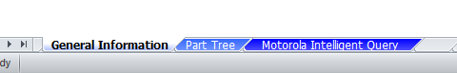

Partial Disclosure Only



Full Disclosure + Partial Disclosure

Once all information has been entered, click the “Check General Information Data” button to verify successful completion of this tab. Once the data has passed the check, continue to the Part Tree Tab.

PLEASE NOTE:

While on this page, if the user experiences this issues/error messages shown in the below two screenshots, it is due to hidden .exd cache files.

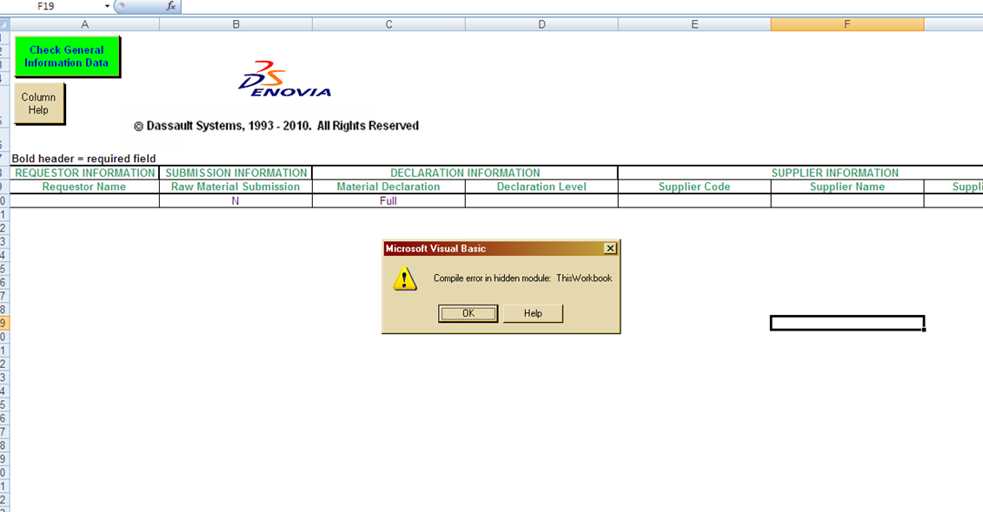

If the user clicks on OK on this error message then the following message maybe displayed. This is also due to hidden .exd cache files.

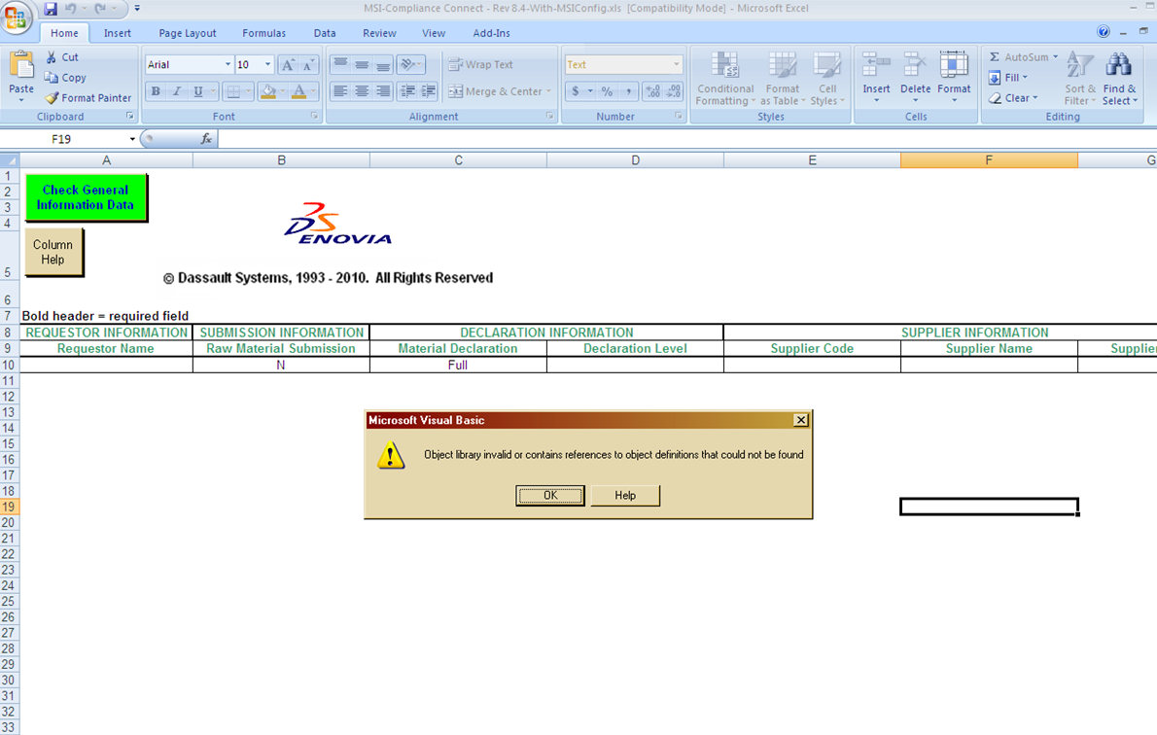

To resolve these errors, the user has to delete the .exd files. since .exd files store cached information about controls installed with a Microsoft Office file. This allows for faster processing of the file. The location of these files differs from one Operating System to another and differ based on the version of Office installed. Please see page 30 for the exact steps to clear this out of the computer’s cache.

## Full or Partial Declaration: Part Tree Tab for Component Information

The Part Tree Tab is used to define the part structure for the saleable parts supplied to the customer. Each level within the part tree of the Bill of Material (BOM) structure is represented in this tab. Begin the part tree by entering the top-level saleable part and components information in the Saleable Parts fields. Refer to Table 2, Part Tree Tab - Saleable Part Guidance, for additional information.

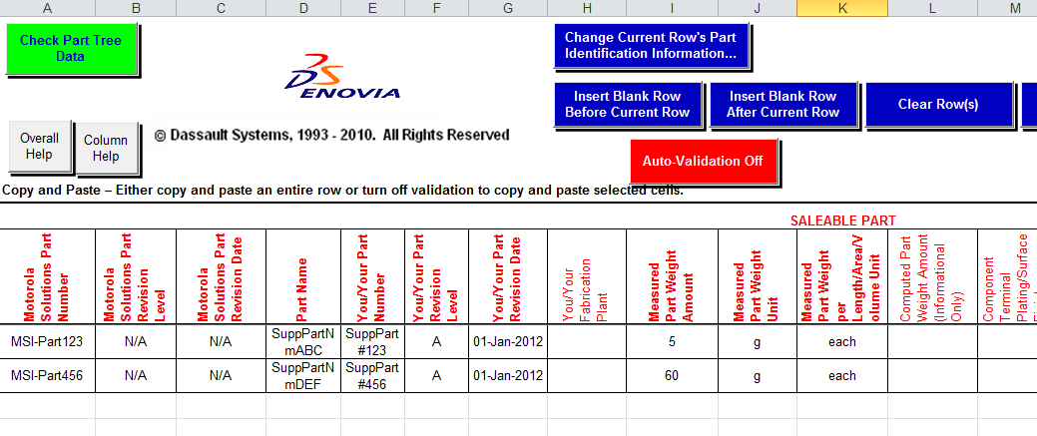

| **Table 2. Part Tree Tab – Salable Part Guidance (Red Headings)** | | |
| --- | --- | --- |
| **Column Name** | **Information Description** | **Status (Required or Optional)** |
| Customer Part Number | Customer saleable part number. | Required |
| Customer Part Revision Level | Revision number of the part. If the customer does not have a revision number, then enter “N/A”. | Required |
| Customer Part Revision Date | Effective revision date of the part. If the customer does not have a revision date, then enter “N/A”. | Required |
| Part Name | Description of part | Required  (N/A for raw material suppliers) |
| Your Part Number | Your Internal Part Number (not necessarily the same as your customer’s part number). | Required |
| Your Part Revision Level | Your revision level of the part. Enter N/A if not used. | Required  (N/A for raw material suppliers) |
| Your Part Revision Date | Effective revision date of the part in your internal systems. Enter N/A if not used. | Required  (N/A for raw material suppliers) |
| Your Fabrication Plant | Enter a comma-separated list of the names of your plants that manufacture this part. Enclose each plant in quotes (“plant1,” “plant2”). | Optional  (N/A for raw material suppliers) |
| Measured Part Weight Amount | Measured weight of the saleable part - finished weight of the part (excluding packaging). | Required  (N/A for raw material suppliers) |
| Measured Part Weight Unit | Select unit of measure for the measured weight entered in the previous column (g, kg, or lb) from the pull-down list. | Required  (N/A for raw material suppliers) |
| Measured Part Weight Per length/area/  volume Unit | If this is a saleable discrete part, set to “each.” If it is a saleable bulk item such as paint, adhesives or lubricants where the Measured Part Weight Amount is function of length, area, or volume, set to appropriate per unit. | Required  (N/A for raw material suppliers) |
| Computed Part Weight | Computed based on sum of the weights of saleable part’s components. Compare to Measure Part Weight Amount.  Computed weight is calculated using the weight of the child components that is either entered on the part tree tab or on the part detail tab.  **Note:** If the Part Detail Tab is completely filled out, the computer part weight column value can be incorrect or simply 0 grams. | Derived  (N/A for raw material suppliers) |
| Column M –Column S | Fields to submit Manufacturing Information | Not Required |
| Eligible Product Application | Choose from the pop-up pick list any eligible Product Level Application that can be claimed for the part | No Required |

If the part is a multipart assembly, enter the complete part breakdown according to the BOM. This information should be entered into the Sub-Part fields to the right on this worksheet. Sub-Parts for each descending level should begin one row beneath its parent assembly in a step-down fashion. No data should be entered in the gray fields throughout the spreadsheet. If the part is not a multipart assembly, the user should leave the Sub-Part fields blank.

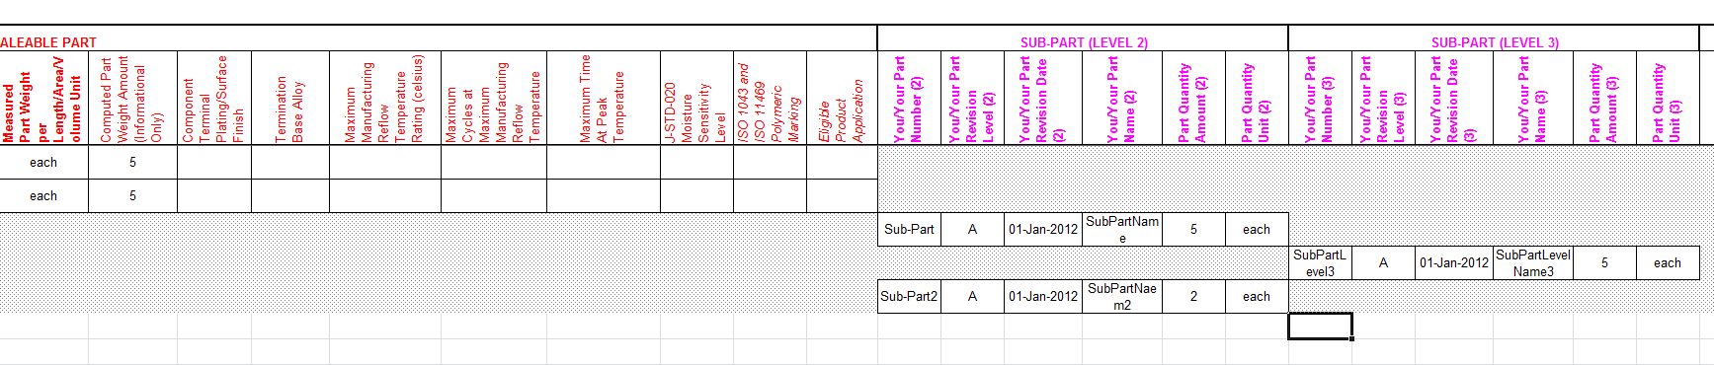

Once all information has been entered, click the “Check Part Tree Data” button to verify successful completion of this tab. Once the data has passed the check, continue to the Materials Tab.

## Full Declaration Only: Materials Tab

The Materials tab is used to document homogenous materials that are used in each lowest-level component as defined in the Part Tree tab. Materials in the material library will be matched with each lowest-level part during the Part Detail tab data entry.

***Note:*** *The Materials Tab will only be visible when the Material Declaration is set to – “Full” on the General Information Tab*

Refer to Table 3a, Materials Tab – Material Guidance, for additional information.

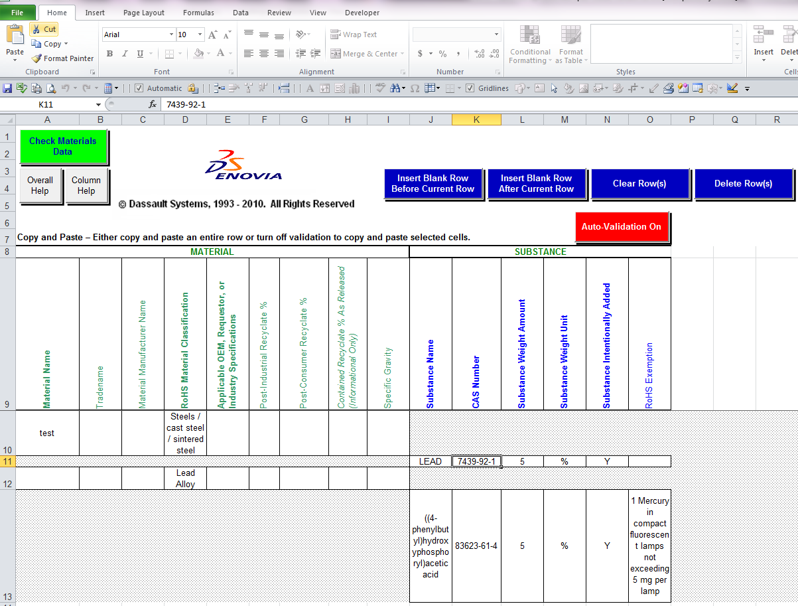

| **Table 3a. Materials Tab – Material Guidance (Green Headings)** | | |
| --- | --- | --- |
| **Column Name** | **Information Description** | **Status (Required or Optional)** |
| Material Name | Enter the material name for the part entered. Name should describe the material (such as steel, plating, nylon). Consult applicable standards for naming guidelines (Steels EN10027, Plastics ISO1043, Aluminum EN 573, Elastomers ISO 1629, Thermoplastic ISO 18064). | Required |
| Tradename | Enter the tradename of the material. | Optional |
| Material Manufacturer Name | Enter the name of the material manufacturer. | Optional |
| RoHS Material Classification | Choose appropriate material classification from the drop down list. | Required |
| Applicable OEM or Requestor or Industry Specifications | Enter a quoted and comma-separated list of any applicable OEM or requestor specifications for this material with the format: “oem:spec,” “oem:spec,” etc. Enter N/A if not applicable.  *Motorola example: W18 spec: Rev P* | Required |
| Pre-Consumer Recyclate % | Enter pre-consumer recyclate % - material weight originated as scrap from the manufacturing process of a different facility and used to create the material entered (scrap metal from a manufacturing process your facility obtained from an outside source, which was melted and used to the create a portion of entered material). Enter ZERO if you do not know the pre-consumer recyclate. | Required |
| Post-Consumer Recyclate % | Enter post-consumer recyclate % - material weight originated as scrap from consumer use and recycled into the entered material (recycled aluminum soda cans, used to create a portion of the entered material). Enter ZERO if you do not know the post-consumer recyclate. | Required |
| Contained Recyclate % As Released (Information Only) | Automatically populated. Sum of the % of the Pre-Consumer and Post-Consumer Recyclate. | Derived |
| Contained Recyclate % As Measured | Enter contained recyclate % as measured. Generally same as % Contained Recyclate as Released. | Optional |
| Specific Gravity | Enter specific gravity of the material. | Optional |

In the same way that sub-parts were entered into the Part Tree tab, the substances (i.e., chemicals) of the material(s) should also be entered in a step-down fashion.



After entering the material information from Table 4, click on the cell lined up with the Substance Name column and one row down from the material information entered. Once the cell is selected, a pop up pick list of chemicals will appear. Search (by name or CAS) and select the appropriate chemical. Click the next row down to add another chemical. The sum of all chemicals entered must total 100% or 1 million parts per million.

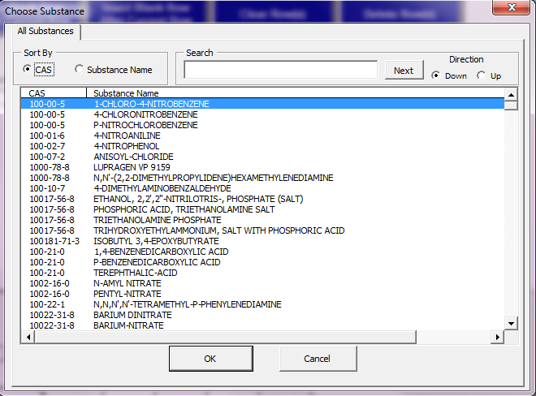

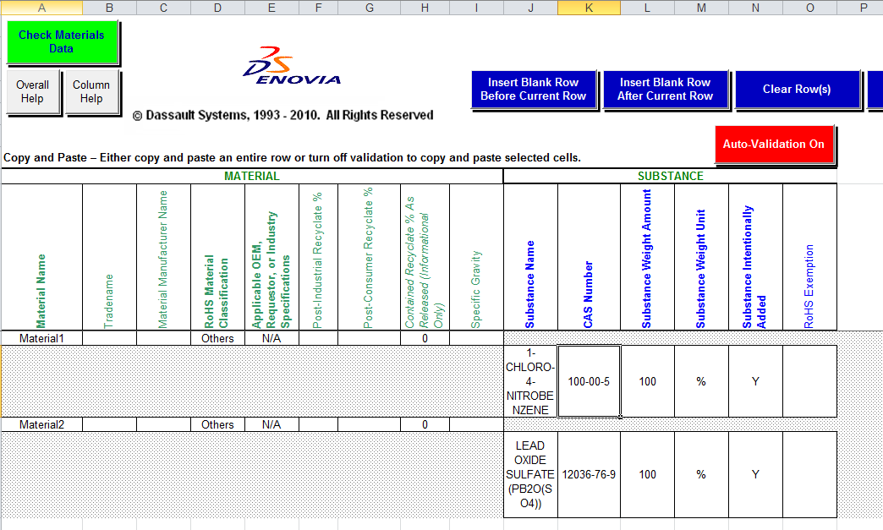

Refer to Table 3b, Materials Tab - Substance Guidance, for additional information.

|  |  |  |
| --- | --- | --- |
| **Table 3b. Materials Tab – Substance Guidance (Blue Headings)** | | |
| **Column Name** | **Information Description** | **Status (Required or Optional)** |
| Substance Name | Select a substance from the pop up box (search by substance name or CAS number).  Once you type in anything (and it is wrong), you must click out of that box to reactivate the pull-down CAS number menu. | Required |
| CAS Number | Chemical Abstracts Service (CAS) number will automatically populate once a substance is chosen. | Required |
| Substance Weight Amount | Enter the amount of the substance as a % or a PPM of the total material. | Required |
| Substance Weight Unit | Select the unit of measure for the substance weight entered in the previous column (% or PPM) from the pull-down list. | Required |
| Substance Intentionally Added | If the selected substance is intentionally added into the homogeneous material, then enter “Yes” otherwise enter “No” | Required |
| RoHS Exemptions | If the selected substance is a restricted substance, then depending on its usage, you can claim an exemption that will make the substance a non-restricted substance. When you click on the cell, the applicable list of exemptions appears in a popup list box.  PLEASE REMEMBER to “match” the exemptions taken on this excel spreadsheet with the exemptions indicated on the Motorola Intelligent Query spreadsheet. | Optional |

Once all the material and substance information has been entered, click the “Check Materials Data” button to verify successful completion of this tab. Once the data has passed the check, continue to the Parts Detail Tab.

## Full Declaration Only: Part Details Tab

The Part Detail tab is used to associate the materials entered in the Material tab to the bottom level parts entered in the Part Tree tab. At least one material must be selected for each bottom level part.

***Note:*** *The Part Details Tab will only be visible when the Material Declaration is set to – = “****Full”*** *on the General Information Tab*

Click on the cell under “Part Number”. A pop-up list box will appear listing all of the lowest level parts in the Part Tree tab. Click “Add Selected” to apply the parts to the spreadsheet.

***Note:*** *Some fields will fill in automatically with the corresponding data entered in the Part Tree tab. Enter any additional part information, as appropriate and/or required.*

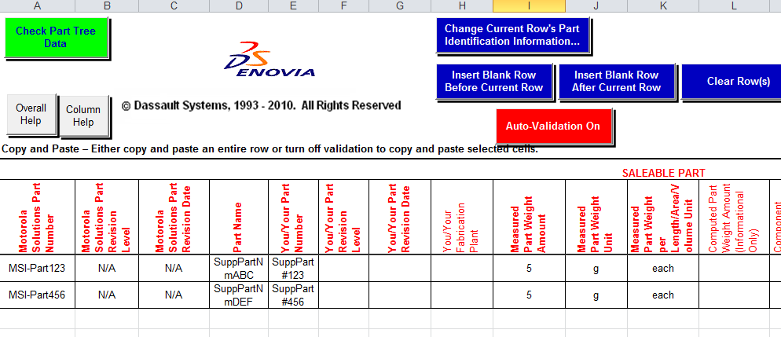

Refer to Table 4a, Part Detail Tab – Part Guidance, for additional information.

| **Table 4a. Part Detail Tab – Part Guidance (Red Headings)** | | |
| --- | --- | --- |
| **Column Name** | **Information Description** | **Status (Required or Optional)** |
| Your Part Number | Click on a part from the pop up box and click "add selected." ***Note:*** It is recommended if more than one bottom level part has been entered in the Part Tree tab, select the first part, enter the data required, and continue with the rest of the parts. | Required |
| Part Revision Level,  Part Revision Date,  Part Name | Information is automatically populated with data entered in the Part Tree tab. | Derived  (N/A for raw material suppliers) |
| Part Weight Amount | Enter weight of the part (same weight entered in Part Tree tab). | Required  (N/A for raw material suppliers) |
| Part Weight Unit | Select unit of measure for the substance weight entered in the previous column (g, kg, or lb) from pull-down list. | Required  (N/A for raw material suppliers) |
| Part Weight per Length/Area/Volume Unit (Information Only) | If this is a saleable discrete part, it will be “each.” If this is a saleable bulk item such as paint, adhesives, or lubricants, where the “Part Weight Amount” is a function of length, area, or volume, then it will be the per length, area, or volume unit. If the actual Part Weight was specified on the Part Tree tab, it will be weight. | Derived  (N/A for raw material suppliers) |
| CFCs (Chlorofluorocarbons) | Select “Y” if CFCs (chlorofluorocarbons) are used in the manufacturing of this part or “N” if not used. | Optional  (N/A for raw material suppliers) |
| Recycling Code Standards | Select all recycling code standards that apply. Click the “Field Help” button for standard definitions. | Optional  (N/A for raw material suppliers) |

Once part information has been entered, click on the cell located one row below the part information and under the “Material Name” columns, and select a material from the pop-up list. Note that the pop-up Material Name List was generated from the material entries created on the Materials tab. Therefore, if a material you need is not on the list, it must be added to the Materials tab in order for it to appear in the Part Detail Tab, Materials List pop-up.

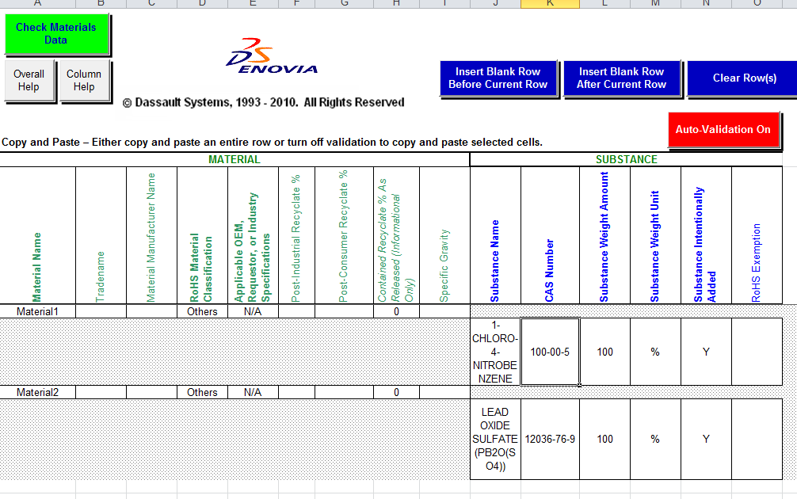

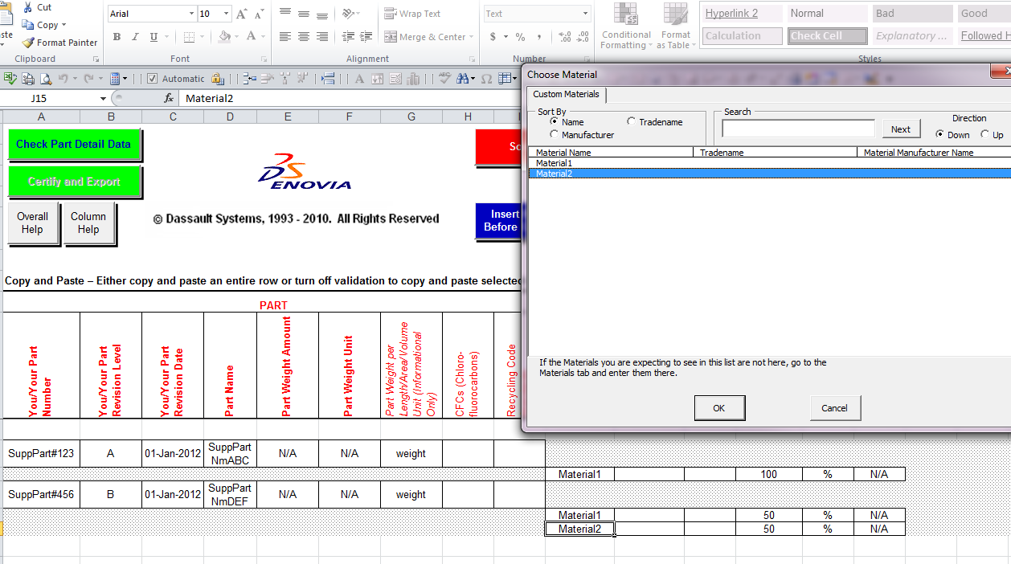

| **Table 4b. Part Detail Tab – Material Guidance (Green Headings)** | | |
| --- | --- | --- |
| **Column Name** | **Information Description** | **Status (Required or Optional)** |
| Material Name | Choose material/materials from the list. | Required |
| Trade Name | Fields will automatically populate. | Derived |
| Material Manufacturer Name | Fields will automatically populate. | Derived |
| Material Weight Amount | Enter amount of the material contained within part. | Required |
| Material Weight Unit | Select unit of measure for material weight entered in the previous column (%, g, kg, or lbs) from the pull-down list. | Required |
| Material Weight Per Length/Area/Volume (Information Only) | Field will automatically populate. | Derived  (N/A for material suppliers) |

Continue clicking on the next available row (or click the add row button), until all the materials have been entered.

Once all the part detail information is entered click the “Check Part Detail Data” button to verify successful completion of this tab. Once the data has passed the check, the “Certify and Export” button will become active. Click on this button and proceed to the next step.

## Partial Declaration Only: “Motorola Intelligent Query” Tab

Based on the Declaration Level chosen on the General Informationtab, the excel file will generate the “Motorola Intelligent Query” tab. This tab will contain all the parts entered in the Part Tree tab. For these parts the user can provide a “Compliance Declaration” for each “Declaration Level” chosen on the “General Information” tab.

***Note:*** *This tab will only be visible when*

* *Material Declaration = Full and Declaration Level is not empty*
* *Material Declaration = Partial and Declaration Level is not empty.*

All Parts from the Part Tree tab are automatically added to the “Motorola Intelligent Query” Tab. Some fields will fill in automatically with the corresponding data entered in the Part Tree tab. Enter any additional part information, as appropriate and/or required.

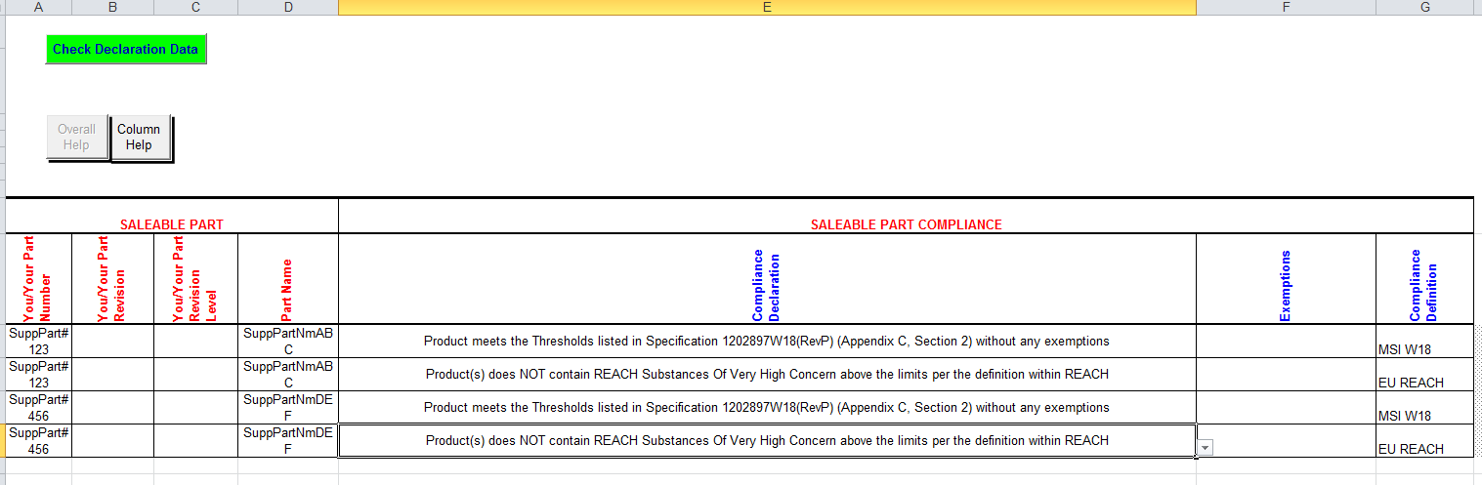

Refer to Table 5, Compliance Definition – Declaration Statement

| **Table 5. “Motorola Intelligent Query” Tab – Declaration Statements (Blue Headings)** | | |
| --- | --- | --- |
| **Column Name** | **Information Description** | **Status (Required or Optional)** |
| Your Part Number | The part number on this sheet is automatically populated based on the data from the Part Tree tab | Derived |
| Part Revision Level,  Part Revision Date,  Part Name | Information is automatically populated with data entered in the Part Tree tab. | Derived |
| Compliance Declaration | Click on the cell’s drop down menu to pick a compliance declaration statement to make for the selected part. | Required |
| Exemptions | If the Compliance Declaration statement claims that the part uses some exemptions, then this field should be populated. Clicking on the Exemptions cell will pop up a list box to choose from.  *\* * *PLEASE remember: any EXEMPTIONS taken on the* ***MATERIALS TAB*** *MUST MATCH the exemptions listed here under the Exemptions column on the* ***MOTOROLA INTELLIGENT QUERY*** *Tab.* * \**  You can add multiple exemptions by holding down the “Ctrl” key and clicking on each exemption needed for that part number. | Required |

## Full or Partial Declaration: “Certify and Export”

After completing and validating all data entry tabs, click the “Certify and Export” button. After clicking the “Certify and Export” button, the spreadsheet will perform final data validation checks and prompt the user to certify that the data entered is accurate to the best of their knowledge. The supplier has the ability to optionally modify the Certification text prior of performing the “Certify and Export” process.

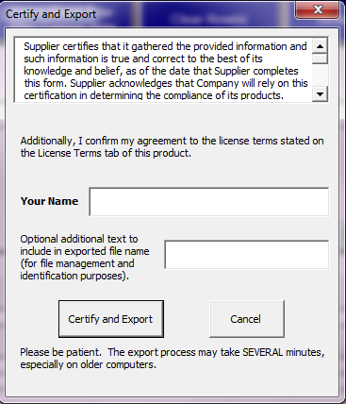

Once certification steps are complete, the Compliance Connect Spreadsheet will create a file with “.mcc” extension and automatically save to user’s computer in the same folder as the “.xls” file is saved.

NOTE: Depending on the location of the excel spreadsheet; the “Optional additional text” box can only hold 10 CHARACTERS! Additional characters will cause a “Run Time Error: 1004” and lock up the form. To avoid such issues, it is recommended that the user saves a working copy of the spreadsheet on the desktop while attempting to certify and export

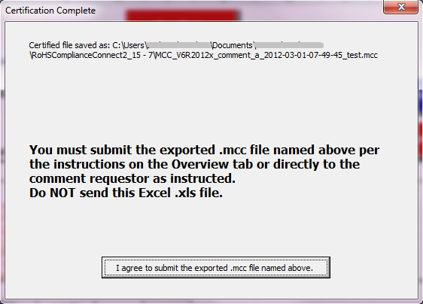

The “.mcc” file should be submitted ***back to the Requestor***. The “.mcc” file is certified and read-only. Therefore, YOUR data submission is protected and cannot be changed by the Requestor. Since the “.mcc” file is much smaller in size, it is easier send via e-mail.

# Utilities Tab

## Import Tab-Delimited Text File

This feature may be useful for populating a spreadsheet with data, such as material library information.

Below is an example of a tab-delimited text file that a supplier would receive from Motorola Solutions that they can use to import into the compliance connect file.

|  |
| --- |
| Worksheet General Information RoHS 17  Moto N Full REACH,RoHS abd Test2 External 1 1 1 1 Moto_123_UniqueID  End Worksheet  Worksheet Part Tree RoHS 17  1 a 01-Jan-2012 a 1 1 01-Jan-2012 5 g each 5  2 a 03-Jan-2012 b 2 1 03-Jan-2012 1 g each 1  5 a 01-Jan-2012 e 5 1 01-Jan-2012 1 g each 1  End Worksheet |

PLEASE NOTE:

While attempting to “Import Tab-Delimited Text File” if the user experiences this issue/error message shown below, it is due to hidden .exd cache files.

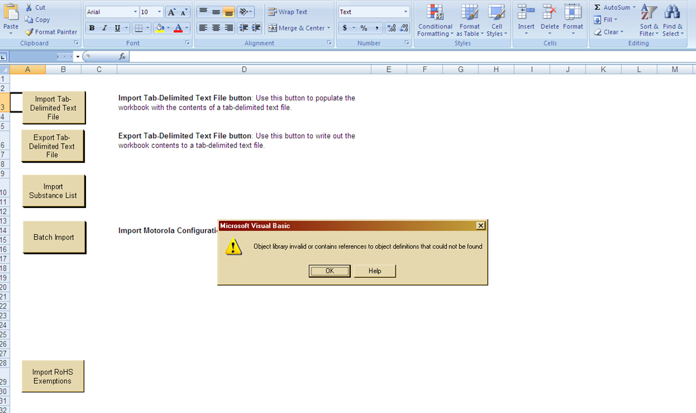

To resolve this error, the user has to delete the .exd files. since .exd files store cached information about controls installed with a Microsoft Office file. This allows for faster processing of the file. The location of these files differs from one Operating System to another and differ based on the version of Office installed. Please see page 30 for the exact steps to clear this out of the computer’s cache.

## Export Tab-Delimited Text File

This feature may be useful for extracting data, such as material library information, for future use in another Compliance Connect Spreadsheet.

A user can fill in a Compliance Connect Spreadsheet, and use the Export Tab-Delimited Text file.

## Import Motorola Configuration File

Periodically, the substance list may be updated to accommodate additional substances. The user may import a Motorola Configuration text file and use the “Batch Import” button with appropriate password to import the file. Please refer to the details in the following file for the contents of the Configuration Import File: Motorola Solutions - CC Import Data File.doc

# Troubleshooting FAQ

## VB Compile Error

This is a common error that some users may experience either due to a corrupt file or because of an update to the Operating System/Office.

If the user experiences this issue, the user will see an error message similar to this:



**Step 1:**

To resolve this error, the user has to delete the .exd files. .exd files store cached information about controls installed in Microsoft Office files to allow for faster processing. The location of these files differs from one Operating System to another and also differs based on the version of MS Office installed.

Following these steps should resolve this issue:

1. Close all Excel documents
2. Open Windows Explorer, navigate to “My Computer”
3. Search for all files with .exd extension (search *.exd in file name)
4. Delete all files with .exd extension
5. Open the Compliance Connect spreadsheet (may have to enable macros again)

These “.exd” files are hidden files on the computer hard drive. Based on the set up of your computer and the kind of privileges you have on your computer, you may not be able to do the following:

1. Search and find the files with .exd extension
2. Delete the files with the .exd extension

In such a situation, please contact your company’s IT administrator/helpdesk so they can perform the above tasks using an administrator account.

Step 2:

If you are running Microsoft Excel 2007, run the following patch from Microsoft: <http://support.microsoft.com/KB/2687441>

If you are running Microsoft Excel 2010, run the following patch from Microsoft: <http://support.microsoft.com/kb/2598039>

Step 3, if needed:

If you are running Microsoft Excel 2010, 32-bit version and your error was not resolved by following steps 1 and 2, please download the following additional Microsoft patch: <http://www.microsoft.com/en-us/download/details.aspx?id=30622>

If steps 1 to 3 do not resolve your errors, please contact MSI for additional assistance at [W18submittal@motorolasolutions.com](javascript:void(location.href='mailto:'+String.fromCharCode(87,49,56,115,117,98,109,105,116,116,97,108,64,109,111,116,111,114,111,108,97,115,111,108,117,116,105,111,110,115,46,99,111,109)))

## Declaration Level Validation Errors

A user may see the following error while importing a pre-populate file into the spreadsheet:

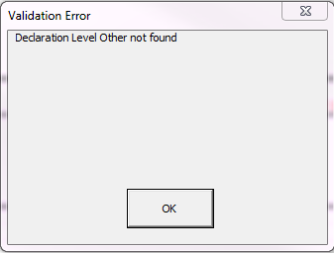

This error occurs when the user attempts to import a pre-populate file using a Declaration Level that is not present/defined in the spreadsheet, then the user notices the following error during the import process. The import process aborts and does not complete. The user can open the prepopulate file, correct the Declaration Level and reimport the file.